
Student Number
Mark / 100

2009

TRIAL HSC EXAMINATION

Chemistry

General Instructions

•Reading time – 5 minutes
•Working time – 3 hours
•Write using black or blue pen
• Draw diagrams using pencil
•Write your Student Number at the top of this page and pages 9, 10,12, 14, 16, 18, 20, 22
•Board-approved calculators may be used
•A data sheet and a Periodic Table are provided at
the back of this paper. This may be removed for your
convenience.

Total Marks – 100

Section I

75 marks

This section has two parts: Part A and Part B

Part A – 15 marks
•Attempt Questions 1- 15
•Allow about 30 minutes for this part

Part B – 60 marks
•Attempt Questions 16 – 27
•Allow about 1 hour and 45 minutes for this
part

Section II Pages 24 – 25

25 marks

•Attempt Question 28.
•Allow about 45 minutes for this section
Confidential
Keep Secure

Section I
75 marks

Part A – 15 marks
Attempt Questions 1-15
Allow about 30 minutes for this part

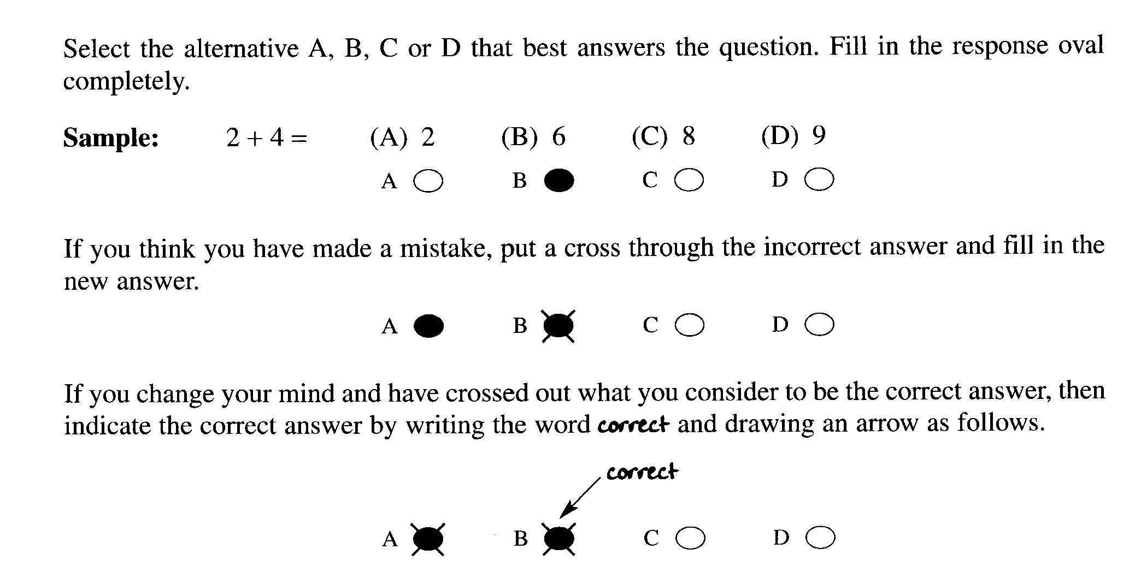

Mark your answers on the ANSWER sheet on page 9
________________________________________________________________________________

1. Which of the statements below describes a transuranic element?

(A) Elements transformed during nuclear reactions.

(B) Elements with atomic number more than 91.

(C) Elements with atomic number less than 92.

(D) Elements that undergo radioactive decay.

2. The table below shows information about a variety of indicators.

Indicator | Colour in low pH | Colour in high pH | pH range
Methyl orange | Red | Yellow | 3.1 - 4.4
Bromophenol blue | Yellow | Blue | 3.0 - 4.6
Methyl red | Pink | Yellow | 4.4 - 6.0
Phenol red | yellow | red | 6.8 - 8.4

Which two indicators could be best used to identify rain with a pH of approximately 6.2?

(A) methyl orange and bromophenol blue

(B) methyl red and phenol red

(C) methyl orange and methyl red

(D) methyl red and bromophenol blue

3. Which equation best represents catalytic cracking of a petroleum fraction?

(A) C₁₆H₃₄(l) 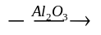C₁₆H₃₄(g)

(B) nC₂H₄(g) → (CH₂—CH₂ )_{n} (s)

(C) C₁₆H₃₄(l) C₇H₁₆(l)   + 3C₂H₄(g) +  C₃H₆(g)

(D) C₇H₁₆(l) + 3 C₂H₄(g) +  C₃H₆(g) C₁₆H₃₄(l)

4. Why is research into synthetic biopolymers attracting great interest?

(A) Synthetic biopolymers decompose more easily than traditional synthetic
polymers.

(B) Synthetic biopolymers can be produced more cheaply than traditional synthetic
polymers.

(C) Synthetic biopolymers have superior physical properties compared to traditional
synthetic polymers.

(D) Synthetic biopolymers have superior chemical properties compared to traditional
synthetic polymers.

5. Refer to the modified periodic table below to answer this question
The table provides information about the Groups to which each element
U, V, W, X, Y, Z belong

I | II |  | III | IV | V | VI | VII | Noble Gases
Y |  |  | V
 |  |  |  |  |  |  | Z
 |  | U
X
 |  |  |  |  |  |  | W

What are the reactions of oxides of these elements with acid and with base?

 | Oxides react with acids | Oxides react with base | Oxide reacts with acid and with base
(A) | Z | X | V
(B) | Y | X | U
(C) | X | Z | V
(D) | V | W | Y

6. Which condensed structural formula represents the ester formed from the reaction of
propanoic acid with 1-heptanol?

(A) CH₃CH₂COOCH₂CH₂CH₂CH₂CH₂CH₂CH₃

(B) CH₃CH₂CH₂CH₂CH₂CH₂COOCH₂CH₃

(C) CH₃CH₂CH₂CH₂COOCH₂CH₂CH₂CH₂CH₃

(D) CH₃CH₂CH₂CH₂CH₂CH₂OCH₂CH₂COOH

The following information refers to questions 7 and 8

Calcium carbonate decomposes to form calcium oxide and carbon dioxide according to the
following equilibrium reaction. This reaction is endothermic.

CaCO₃(s) 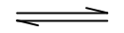 CaO(s) + CO₂(g)

7. What mass of calcium carbonate is needed to form 5.00 L of carbon dioxide at 25ºC and 100 kPa?

(A) 1.238 g

(B) 10.51 g

(C) 20.19 g

- 22.04 g

8. What would happen if the reaction at equilibrium suddenly has its volume decreased?

(A) The reaction shifts to the right, favouring the formation of CaO.

(B) The reaction shifts to the right, favouring the formation of CO₂.

(C) The reaction shifts to the left, favouring the formation of CaCO₃.

- The reaction shifts to the left, favouring the formation of CO₂.

9. Which conditions would promote the greatest increase in the pH of an aqueous
solution of carbon dioxide?

(A) Addition of CO₂ and cooling

(B) Addition of H₂O and heating

(C) Addition of carbonic acid

(D) Cooling the reaction

10. Which chemical would have the highest boiling point?

(A) butane

(B) propanoic acid

(C) 1-butanol

(D) butanoic acid

11 Given the following reaction:

HClO₄ + CH₃COOH CH₃COOH₂⁺ + ClO₄⁻

Which species are acting as Bronsted-Lowry acids in this reaction?

(A) HClO₄ and ClO₄⁻

(B) CH₃COOH and HClO₄

(C) HClO₄ and CH₃COOH₂⁺

(D) CH₃COOH and ClO₄⁻

12. Consider the following compounds:

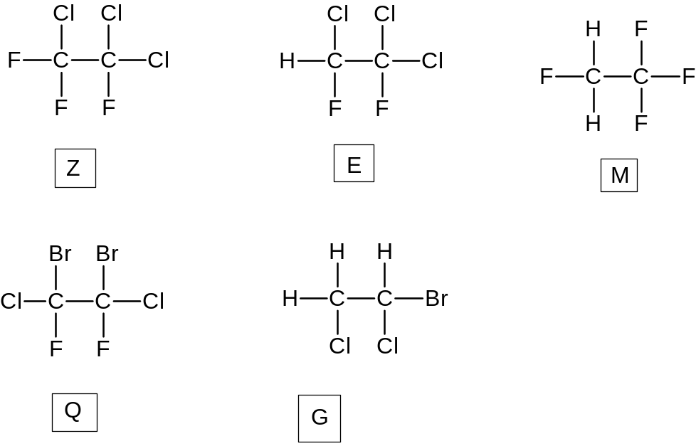

Choose the set which classifies Z, E, M, Q and G correctly

 | Z | E | M | Q | G
(A) | haloalkane | HFC | HCFC | halon | CFC
(B) | CFC | HFC | HCFC | haloalkane | halon
(C) | CFC | HCFC | HFC | halon | haloalkane
(D) | CFC | HCFC | halon | HFC | haloalkane

13. A water sample was found to have a pH of 1.2. Which ion is likely to be absent in the water
sample?

(A) chloride

(B) carbonate

(C) sulfate

(D) nitrate

14. Which quality of water is being tested by determining the percentage of light that is
transmitted or scattered, in the absence of added reagents, through a standard depth of
water?

(A) NTU

(B) TDS

(C) BOD

(D) Turbidity

15. Ginny, Hermione, Luna and Cho were each given different unknown solutions
containing only one cation. The unknown ions may be sodium, barium, iron and copper.

The students tested their solutions with sulfate, carbonate and chloride ions. Their results are
given in the table. Cho had a blue coloured solution. The others had colourless solutions.

Analyst | sulfate | carbonate | chloride
Ginny | precipitate | precipitate | no precipitate
Hermione | no precipitate | no precipitate | no precipitate
Luna | no precipitate | precipitate | no precipitate
Cho | no precipitate | precipitate | no precipitate

What ion did they each have?

 | Ginny | Hermione | Luna | Cho
(A) | barium | sodium | iron | copper
(B) | iron | sodium | barium | copper
(C) | sodium | barium | iron | copper
(D) | barium | iron | sodium | copper

Student Number …………………………….

Section I MARKS -----/15
Part A
Multiple Choice Answer Sheet

1. A  B  C  D 

2. A  B  C  D 

3. A  B  C  D 

4. A  B  C  D 

5. A  B  C  D 

6. A  B  C  D 

7. A  B  C  D 

8. A  B  C  D 

9. A  B  C  D 

10. A  B  C  D 

11. A  B  C  D 

12. A  B  C  D 

13 A  B  C  D 

14. A  B  C  D 

15. A  B  C  D 

Student No. ………………………………..
Part B. 60 marks
Attempt questions 16 to 27
Allow about 1 hour and 45 minutes for this part
Show all relevant working in questions involving calculations
MARKS
Question 16 (5 marks)

The table shows properties of some fuels.

FUEL | MAIN SOURCE | Heat of Combustion  (kJ g⁻¹) | Boiling Point  (⁰C)
Methane | Petrochemical industry | 55.6 | -161.5
Propane | Petrochemical industry  Natural Gas | 50.3 | -42.1
Octane | Refined from crude oil | 47.9 | 125.7
Ethanol | Hydration of ethane  Fermentation | 29.7 | 78.3

Assess the potential of ethanol as an alternative fuel. 5

.....................................................................................................................................................................

.....................................................................................................................................................................

.....................................................................................................................................................................

.....................................................................................................................................................................

.....................................................................................................................................................................

.....................................................................................................................................................................

.....................................................................................................................................................................

.....................................................................................................................................................................

.....................................................................................................................................................................

.....................................................................................................................................................................

.....................................................................................................................................................................

.....................................................................................................................................................................

.....................................................................................................................................................................

.....................................................................................................................................................................
MARKS

Question 17 (4 marks)

You have studied one of the cells: (i) The Dry Cell Battery (ii) The Lead Acid Battery
Answer the questions using one of the cells.

(a) State ONE environmental impact associated with the cell you have chosen. 1

......................................................................................................................................................

......................................................................................................................................................

......................................................................................................................................................

......................................................................................................................................................

......................................................................................................................................................

(b) Describe the chemistry of the cell you have chosen. 3

......................................................................................................................................................

......................................................................................................................................................

......................................................................................................................................................

......................................................................................................................................................

......................................................................................................................................................

......................................................................................................................................................

......................................................................................................................................................

......................................................................................................................................................

The test continues next page..
Student Number …………………………………..
MARKS
Question 18 (7marks)

(a) Draw, in the space below, a scientifically labeled diagram of the following galvanic cell
in operation : . 3

Ni / Ni²⁺ and Ag⁺ / Ag

(b) Write the anode half-equation for the above galvanic cell 1

........................................................................................................................................................

(c) Write the cathode half-equation for the above galvanic cell 1

...................................................................................................................................................

(d) Use the standard reduction potential table to calculate the E⁰ potential of the above
galvanic cell. Show all working 2

........................................................................................................................................................

........................................................................................................................................................

........................................................................................................................................................

Test continues next page

MARKS
Question 19 (5 marks)

A student carried out a first-hand investigation to determine the heat of combustion of ethanol
using a spirit-burner. The student heated 200 mL of water in a beaker for 3 minutes and recorded
results of the investigation in the table below :

Initial mass of burner | 213.27 g
Final mass of burner | 212.58 g
Mass of fuel used | 0.69 g
Mass of water heated | 200.00 g
Initial temperature of water | 18.00 ºC
Final temperature of water | 40.00 ºC

(a) Write a balanced equation for the combustion of ethanol including states. 1

.......................................................................................................................................................

(b) Calculate the molar heat of combustion of ethanol. 3

.......................................................................................................................................................

.......................................................................................................................................................

.......................................................................................................................................................

.......................................................................................................................................................

.......................................................................................................................................................

.......................................................................................................................................................

.......................................................................................................................................................

(c) Suggest a reason why the experimental value is less than the theoretical ∆H value
of −1364 kJmol⁻¹ 1

.......................................................................................................................................................

.......................................................................................................................................................

.......................................................................................................................................................

.......................................................................................................................................................
Student Number …………………………….
MARKS
Question 20 (3 marks)

Explain why alkanes and their corresponding alkenes have similar physical properties,
but very different chemical properties. 3

.....................................................................................................................................................................

.....................................................................................................................................................................

.....................................................................................................................................................................

.....................................................................................................................................................................

.....................................................................................................................................................................

.....................................................................................................................................................................

.....................................................................................................................................................................

.....................................................................................................................................................................

Question 21 (3 marks)

Explain the differences in pH values that would be observed for 0.05 molL⁻¹ solutions of
acetic, citric and hydrochloric acids. 3

....................................................................................................................................................................

...................................................................................................................................................................

...................................................................................................................................................................

...................................................................................................................................................................

...................................................................................................................................................................

...................................................................................................................................................................

Test continues next page
MARKS
Question 22 (5 marks)

(a) State one industrial source of oxides of sulfur. 1

..............................................................................................................................................

...............................................................................................................................................

(b) Write a chemical equation to show the formation of one type of oxide of nitrogen. 1

...................................................................................................................................................

- Explain the concern about the release of oxides of nitrogen into the environment. 2

...................................................................................................................................................

...................................................................................................................................................

...................................................................................................................................................

...................................................................................................................................................

(d) Describe how you would assess the validity of the information gathered about the atmospheric
concentrations of oxides of sulfur and nitrogen. 1

..........................................................................................................................................................

...........................................................................................................................................................

...........................................................................................................................................................

..........................................................................................................................................................

..........................................................................................................................................................

Test continues next page

Student Number …………………………….

MARKS
Question 23 (2 marks)

(a) Calculate the pH of a 0.25 molL⁻¹ solution of nitric acid. 1

.......................................................................................................................................................

.......................................................................................................................................................

.......................................................................................................................................................

(b) Describe the effect on the pH if the nitric acid is diluted with demineralised water. 1

.......................................................................................................................................................

.......................................................................................................................................................

.......................................................................................................................................................

Test continues next page

Question 24 (8 marks)

Anna Lizt is a technology-oriented student of Esur Semaj High School. Anna wanted to analyse the
acid content of a certain diprotic food acid (H₂A) using two titration techniques for endpoint determination:
the indicator method and the pH probe method.

Table 1 outlines the steps of the analysis Anna followed. Table 2 gives the results of the analysis.

TABLE 1
Step | Indicator method | pH probe method
1 | 5.214 g of a solid monoprotic primary standard acid (MW = 204.22 g mol⁻¹) weighed, dissolved and diluted to 250.00 mL in a 250-mL volumetric flask.
2 | 25.00 mL aliquot of the acid is pipetted into a 250-mL conical flask | 25.00 mL aliquot of the acid is pipetted into a 250-mL beaker
3 | two drops of phenolphthalein added to the flask | a magnetic stirring bar and a pH probe (connected to a data logger) are inserted into the beaker.
4 | burette is filled with NaOH solution | burette is filled with NaOH solution, the magnetic stirrer turned on and the data logger activated
5 | NaOH solution added dropwise until the colourless solution turns light pink | NaOH solution added incrementally and the pH monitored after each addition. A graph of pH against volume of added NaOH solution exhibits an S shaped curve
6 | 25.00 mL of food acid is diluted to 250.00 mL in a volumetric flask
7 | Steps 1-5 repeated 3 times
8 | Steps 1-5 done 4 times substituting food acid (H₂A) solution instead of the standard acid solution  An average titre of 38.45 mL was obtained for the pH probe technique

Question 24 contnues next page

Student Number …………………………….
MARKS
TABLE 2
Standardisation NaOH
Trial | Titre (mL)
Trial | Indicator method | pH probe
1 | 22.51 | 22.48
2 | 22.31 | 22.28
3 | 22.37 | 22.30
4 | 22.28 | 22.32

(a) What rinsing protocol is required for step 2 in the indicator method given in Table 1? 1

.......................................................................................................................................................

.......................................................................................................................................................

.......................................................................................................................................................

(b) Explain the need to standardise the NaOH with a primary standard solution instead of
just preparing a standard solution of NaOH by weighing. solid NaOH. 1

.........................................................................................................................................................

.........................................................................................................................................................

.........................................................................................................................................................

(c) Calculate the concentration of the standard acid solution in mol L⁻¹ 1

...........................................................................................................................................................

...........................................................................................................................................................

...........................................................................................................................................................

(d) Calculate the concentration of the NaOH solution.using the pH probe method. 1

.........................................................................................................................................................

..........................................................................................................................................................

...........................................................................................................................................................

...........................................................................................................................................................
Question 24 contnues next page

MARKS
(e) Calculate the concentration (in mol L⁻¹ ) of the diprotic food acid (H₂A) using the
pH probe technique. 2

.........................................................................................................................................................

..........................................................................................................................................................

...........................................................................................................................................................

...........................................................................................................................................................

(f) Which of the techniques gave more reliable results for the standardisation of the
NaOH? Explain a possible reason for this. 2

.................................................................................................................................................

.................................................................................................................................................

.................................................................................................................................................

.................................................................................................................................................

Question 25 (3 marks)

Justify the need for monitoring combustion reactions. Use balanced formula equations to
support your answer. 3

..................................................................................................................................................................

..................................................................................................................................................................

..................................................................................................................................................................

..................................................................................................................................................................

..................................................................................................................................................................

Test continues next page

Student Number …………………………………..
MARKS
Question 26 (5 marks)

Mercurio Krum is a very inquisitive high school student. Mercurio suspected that his home’s
water supply has an unusually high level of copper ions from the household’s copper water pipes as
the water tasted awful. He therefore asked his university friend to help him do an AAS analysis of the water samples from his home.
To do this,
- He took early morning water samples for five consecutive days.
- He pipetted 50.00 mL of his water sample into a 100.00 mL volumetric flask and then
diluted it to the mark. He did this for all his samples
- He also prepared six standard copper solutions

The complete result of the analysis are tabulated in the table:

Sample | ppm Cu²⁺ | Absorbance
Standard 1 | 0.21 | 0.102
Standard 2 | 0.32 | 0.203
Standard 3 | 0.42 | 0.300
Standard 4 | 0.52 | 0.401
Standard 5 | 0.61 | 0.502
Standard 6 | 0.71 | 0.601
water sample | unknown | Ave 0.557

(a) Use the grid below to prepare a labeled calibration curve of the results. 2



Question 26 contnues next page

MARKS

(b) Use your graph to determine the concentration of the water sample in ppm as obtained
from the experiment. 1

...................................................................................................................................................

...................................................................................................................................................

(c) Calculate the Cu²⁺ concentration of the undiluted water sample in molL⁻¹ 1

...................................................................................................................................................

..................................................................................................................................................

..................................................................................................................................................

..................................................................................................................................................

(d) Mercurio consulted the internet and found that the Cu²⁺ concentration in drinking water to be
safe for drinking must not exceed 1300 μg L⁻¹ ( 10⁻⁶g = 1 microgram (μg)). Should
Mercurio recommend to his parents to replace the old water pipes with new ones?
Justify your answer. 1

.................................................................................................................................................

.................................................................................................................................................

.................................................................................................................................................

.................................................................................................................................................

Test continues next page

Student Number ………………………………..

MARKS
Question 27 (4 marks)

Explain the following characteristics of ozone and oxygen in terms of structure and/or bonding.

(a) Ozone is more reactive than oxygen. 2

.........................................................................................................................................

.........................................................................................................................................

.........................................................................................................................................

(b) Ozone has a higher boiling point than oxygen. 2

............................................................................................................................................

............................................................................................................................................

............................................................................................................................................

............................................................................................................................................

Test continues next page

MARKS

Question 28 (6 marks)

Describe and assess the effectiveness of methods used to sanitise mass water supply. 6

........................................................................................................................................................................

.......................................................................................................................................................................

.......................................................................................................................................................................

.......................................................................................................................................................................

.......................................................................................................................................................................

.......................................................................................................................................................................

.......................................................................................................................................................................

.......................................................................................................................................................................

.......................................................................................................................................................................

.......................................................................................................................................................................

.......................................................................................................................................................................

........................................................................................................................................................................

.......................................................................................................................................................................

.......................................................................................................................................................................

.......................................................................................................................................................................

.......................................................................................................................................................................

.......................................................................................................................................................................

.......................................................................................................................................................................

.......................................................................................................................................................................

.......................................................................................................................................................................

.......................................................................................................................................................................

.......................................................................................................................................................................

Test continues next page

2009 TRIAL HIGHER SCHOOL CERTIFICATE EXAMINATION

CHEMISTRY

Section II

Question 29: Industrial Chemistry

25 marks
Allow about 45 minutes for this section

Answer the questions in a writing booklet. Extra writing booklets are available.
Show all relevant working in questions involving calculations.

MARKS
(a) The table shows the effect of temperature on the equilibrium constant (K)
for the Contact Process.

2SO₂ (g) + O₂ (g) 2SO₃ (g)

Temperature ⁰C | K
700 | 2.63
800 | 0.915
900 | 0.384
1000 | 0.184
1100 | 0.098

(i) Is the reaction endothermic or exothermic? Use the values in the table to explain
your answer. 2

(ii) Give the equilibrium expression for the reaction in the Contact Process at 700⁰C 1

(iii) Sulfur trioxide is easily converted to sulfuric acid by adding it to water.
However, in the Contact Process, an intermediate step is taken for safety
reasons.

Identify the intermediate step and give an explanation for the necessity
of this step in the process. 3

Question 29 continues next page

MARKS

(b) In your practical work you performed a first hand investigation to demonstrate the effect
of soap as an emulsifier.

(i) Describe your procedure. 2

(ii) Explain the effect of soap as an emulsifier in your investigation. 3

(c) Analyse the changes that have occurred in the use of electrolysis for the industrial
production of sodium hydroxide 6

(d) The Solvay process has been in use since the 1860s.
.

(i) Identify the raw materials used in the Solvay Process. 1

(ii) Write a chemical equation to show how ammonia is recovered for reuse in the
Solvay Process. 1

(iii) Calculate the volume of ammonia recovered from 500 kg of ammonium
chloride at 25 ºC and 100 kPa. 2

(iv) Discuss two criteria that need to be considered when determining the
location of a Solvay plant. 4

End of Test 

